A2614-Eur-Sweden-Ringerike-Applique-1000 CE

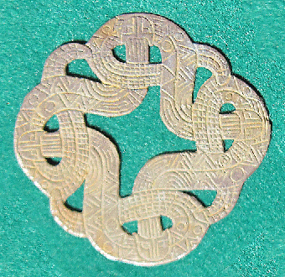 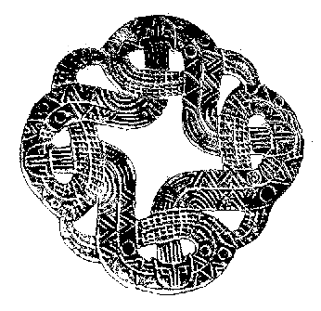

**Ringerike**

The first half of the 11th century featured the Ringerike style in Viking art.

The Ringerike Style receives its name from the [Ringerike](https://en.wikipedia.org/wiki/Ringerike_(traditional_district)" \o "Ringerike (traditional district)) district north of [Oslo](https://en.wikipedia.org/wiki/Oslo), Norway, where the local reddish [sandstone](https://en.wikipedia.org/wiki/Sandstone) was widely employed for carving stones with designs of the style.[[14]](https://en.wikipedia.org/wiki/Viking_art#cite_note-14)

[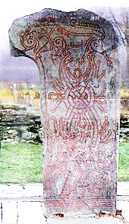](https://en.wikipedia.org/wiki/File:Vangsteinen.JPG)

The Vang Stone

The type object most commonly used to define Ringerike Style is a 2.15-metre (7 ft 1 in) high [carved stone](https://en.wikipedia.org/wiki/Vang_stone) from [Vang](https://en.wikipedia.org/wiki/Vang,_Oppland" \o "Vang, Oppland) in [Oppland](https://en.wikipedia.org/wiki/Oppland). Apart from a runic memorial inscription on its right edge, the main field of the Vang Stone is filled with a balanced [tendril](https://en.wikipedia.org/wiki/Tendril) ornament springing from two shell spirals at the base: the main stems cross twice to terminate in lobed tendrils. At the crossing, further tendrils spring from loops and pear-shaped motifs appear from the tendril centres on the upper loop. Although axial in conception, a basic asymmetry arises in the deposition of the tendrils. Surmounting the tendril pattern appears a large striding animal in double-contoured rendering with spiral hips and a lip lappet. Comparing the Vang Stone animal design with the related animal from the Mammen axe-head, the latter lacks the axiality seen in the Vang Stone and its tendrils are far less disciplined: the Mammen scroll is wavy, while the Vang scroll appears taut and evenly curved, these features marking a key difference between Mammen and Ringerike ornament. The inter-relationship between the two styles is obvious, however, when comparing the Vang Stone animal with that found on the [Jelling Stone](https://en.wikipedia.org/wiki/Jelling_Stone).

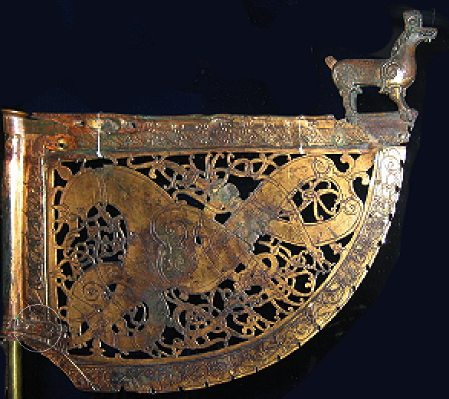

The Söderala weathervane.

With regard to metalwork, Ringerike Style is best seen in two copper-gilt [weather-vanes](https://en.wikipedia.org/wiki/Weather-vane), from Källunge, Gotland and from Söderala, Hälsingland, both in Sweden. The former displays one face two axially-constructed loops in the form of snakes, which in turn sprout symmetrically-placed tendrils. The snake heads, as well as the animal and snake on the reverse, find more florid treatment than on the Vang Stone: all have lip lappets, the snakes bear pigtails, while all animals have a pear-shaped eye with the point directed towards the snout – a diagnostic feature of Ringerike Style.

Scandinavians had served as mercenaries in the Roman army many centuries before the Viking Age,[[8]](http://www.wikiwand.com/en/Greece_runestones#citenoteHarrison378) but during the time when the stones were made, there were more contacts between Scandinavia and Byzantium than at any other time.[[9]](http://www.wikiwand.com/en/Greece_runestones#citenotejansson439) Swedish Viking ships were common on the [Black Sea](http://www.wikiwand.com/en/Black_Sea), the [Aegean Sea](http://www.wikiwand.com/en/Aegean_Sea), the [Sea of Marmara](http://www.wikiwand.com/en/Sea_of_Marmara) and on the wider [Mediterranean Sea](http://www.wikiwand.com/en/Mediterranean_Sea).[[9]](http://www.wikiwand.com/en/Greece_runestones#citenotejansson439) Greece was home to the [Varangian Guard](http://www.wikiwand.com/en/Varangian_Guard), the elite bodyguard of the [Byzantine Emperor](http://www.wikiwand.com/en/Byzantine_Emperor),[[10]](http://www.wikiwand.com/en/Greece_runestones#citenoteLarsson110) and until the [Komnenos dynasty](http://www.wikiwand.com/en/Komnenos_dynasty) in the late 11th century, most members of the Varangian Guard were [Swedes](http://www.wikiwand.com/en/Swedes_(Germanic_tribe)).[[11]](http://www.wikiwand.com/en/Greece_runestones#citenotevarang22311) As late as 1195, Emperor [Alexios Angelos](http://www.wikiwand.com/en/Alexios_III_Angelos) sent emissaries to [Denmark](http://www.wikiwand.com/en/Denmark), [Norway](http://www.wikiwand.com/en/Norway) and Sweden requesting 1,000 warriors from each of the three kingdoms.[[12]](http://www.wikiwand.com/en/Greece_runestones#citenotebrate6412) Stationed in [Constantinople](http://www.wikiwand.com/en/Constantinople), which the Scandinavians referred to as Miklagarðr (the "Great City"), the Guard attracted young Scandinavians of the sort that had composed it since its creation in the late 10th century.

The large number of men who departed for the Byzantine Empire is indicated by the fact that the [medieval Scandinavian laws](http://www.wikiwand.com/en/Medieval_Scandinavian_laws) still contained laws concerning voyages to Greece when they were written down after the Viking Age.[[9]](http://www.wikiwand.com/en/Greece_runestones#citenotejansson439) The older version of the [Westrogothic law](http://www.wikiwand.com/en/Westrogothic_law), which was written down by [Eskil Magnusson](http://www.wikiwand.com/en/Eskil_Magnusson), the [lawspeaker](http://www.wikiwand.com/en/Lawspeaker) of [Västergötland](http://www.wikiwand.com/en/V%C3%A4sterg%C3%B6tland) 1219–1225, stated that "no man may receive an inheritance (in Sweden) while he dwells in Greece". The later version, which was written down from 1250 to 1300, adds that "no one may inherit from such a person as was not a living heir when he went away". Also the old Norwegian [Gulaþingslög](http://www.wikiwand.com/en/Gulating) contains a similar law: "but if (a man) goes to Greece, then he who is next in line to inherit shall hold his property".[[11]](http://www.wikiwand.com/en/Greece_runestones#citenotevarang22311)

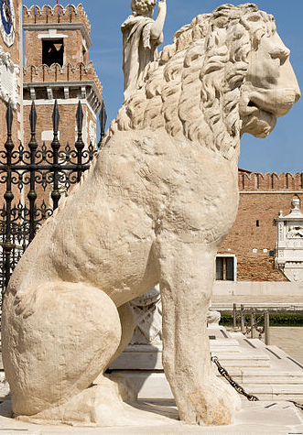 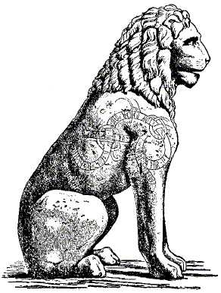 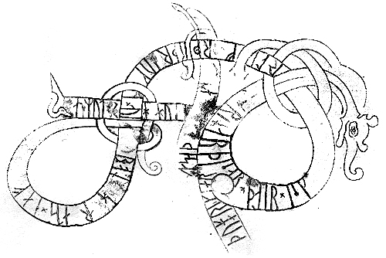

The [Piraeus Lion](http://www.wikiwand.com/en/Piraeus_Lion) runic inscription in Ringerike Style in Venice

[[10]](http://www.wikiwand.com/en/Piraeus_Lion#citenote10)[[11]](http://www.wikiwand.com/en/Piraeus_Lion#citenote11)

Right side of the lion:

* **ASMUDR : HJU :** RU**NAR : ÞISAR : ÞAIR : ISK**IR : AUK: ÞU**RLIFR : ÞURÞR : AUK : IVA**R : AT : **BON : H**A**RADS :** H**AF**A : **ÞUAT : GRIK**I**AR :** UF : H**UGSA**ÞU : AUK : B**A**NAÞU :
  + Asmund cut these runes with Asgeir and Thorleif, Thord and Ivar, at the request of Harold the Tall, though the Greeks considered about and forbade it.

Left side of the lion:

* **HAKUN : VAN: ÞI**R**: ULFR :** A**UK : ASM**U**D**R : A**UK : A**U**RN : HAFN : ÞESA : ÞIR : M**E**N : L**AG**ÞU : A : U**K**: HARAD**R**: HA**F**I : UF IABUTA : UPRA**R**S**TAR : **V**EGNA : **GRI**K**IAÞIÞS : VARÞ : DALK**R**: N**A**U**ÞUGR : I : F**IAR**I : LAÞUM : EGIL : VAR : **I** : FARU : **MIÞ :** RAGNAR**R : TIL :** RU**MAN**IU **. . . . AUK : A**RMENIU :
  + Hakon with Ulf and Asmund and Örn conquered this port. These men and Harold Hafi imposed a heavy fine on account of the revolt of the Greek people. Dalk is detained captive in far lands. Egil is gone on an expedition with Ragnar into [Romania](http://www.wikiwand.com/en/Byzantine_Empire) and [Armenia](http://www.wikiwand.com/en/Armenia).

Some have tried to trace [Harald Hardrade](http://www.wikiwand.com/en/Harald_Hardrade)'s name on the inscription, but the time it was carved does not coincide with his time in the service of the emperor.[[12]](http://www.wikiwand.com/en/Piraeus_Lion#citenote12)

Erik Brate's translation

[Erik Brate](http://www.wikiwand.com/en/Erik_Brate)'s interpretation from 1914 is considered to be the most successful one.[[9]](http://www.wikiwand.com/en/Piraeus_Lion#citenotePritsak3489)

|  |  |  |
| --- | --- | --- |
| **hiuku þir hilfninks milum**  **hna en i hafn þesi þir min**  **eoku runar at haursa bunta**  **kuþan a uah**  **riþu suiar þita linu**  **fur raþum kul uan farin**  -  **tri(n)kiar ristu runar**  **[a rikan strin]k hiuku**  **þair isk[il-] [þu]rlifr**  -  **litu auka ui[i þir a]**  **roþrslanti b[yku] -**  **a sun iuk runar þisar.**  **ufr uk - li st[intu]**  **a[t haursa]**  **kul] uan farn**[[9]](http://www.wikiwand.com/en/Piraeus_Lion" \l "citenotePritsak3489) | They cut him down in the midst of his  forces. But in the harbor the men cut  runes by the sea in memory of Horsi, a  good warrior.  The Swedes set this on the lion.  He went his way with good counsel,  gold he won in his travels.  The warriors cut runes,  hewed them in an ornamental scroll.  Æskell (Áskell) [and others] and  Þorlæifʀ (Þorleifr)  had them well cut, they who lived  in [Roslagen](http://www.wikiwand.com/en/Roslagen). [N. N.] son of [N. N.]  cut these runes.  Ulfʀ (Úlfr) and [N. N.] colored them  in memory of Horsi.  He won gold in his travels.[[9]](http://www.wikiwand.com/en/Piraeus_Lion#citenotePritsak3489) |  |

* [sv:Sven B.F. Jansson](http://www.wikiwand.com/sv/Sven_B.F._Jansson), "Pireuslejonets runor", Nordisk Tidskrift för vetenskap konst och industri, utgiven av Letterstedtska Föreningen. Stockholm (1984).
  + [**^**](http://www.wikiwand.com/en/Piraeus_Lion#cite_ref-1) Encyclopædia Britannica, Athens, The Acropolis, p.6/20, 2008, O.Ed.
  + [**^**](http://www.wikiwand.com/en/Piraeus_Lion#cite_ref-2) Cornelius Vermeule, "Greek Funerary Animals, 450-300 B. C.", American Journal of Archaeology **76**:1:49-59 (January 1972), [JSTOR](http://www.wikiwand.com/en/JSTOR) [503610](https://www.jstor.org/stable/503610), p. 53
  + [**^**](http://www.wikiwand.com/en/Piraeus_Lion#cite_ref-3) Goette, Hans Rupprecht (2001), [Athens, Attica and the Megarid: An Archaeological Guide](https://books.google.com/books?id=FRHY3zWyrcEC). [Routledge](http://www.wikiwand.com/en/Routledge). p. 141. [ISBN](http://www.wikiwand.com/en/International_Standard_Book_Number) [0-415-24370-X](http://www.wikiwand.com/en/Special:BookSources/0-415-24370-X)
  + [**^**](http://www.wikiwand.com/en/Piraeus_Lion#cite_ref-4) Ellis, Henry (1833). [The British Museum. Elgin and Phigaleian Marbles](https://books.google.com/books?id=1K_TIaJxo8EC&printsec=frontcover&source=gbs_ge_summary_r&cad=0#v=onepage&q&f=false). [British Museum](http://www.wikiwand.com/en/British_Museum). p. 36.
  + [**^**](http://www.wikiwand.com/en/Piraeus_Lion#cite_ref-5) Jarring, Gunnar (1978). ["Evliya Celebi och Marmorlejonet från Pireus"](http://fornvannen.se/pdf/1970talet/1978_001.pdf) (PDF). [Fornvännen](http://www.wikiwand.com/en/Fornv%C3%A4nnen). [Swedish National Heritage Board](http://www.wikiwand.com/en/Swedish_National_Heritage_Board). **85**: 1–4. [ISSN](http://www.wikiwand.com/en/International_Standard_Serial_Number) [1404-9430](http://www.worldcat.org/issn/1404-9430). Retrieved 5 September 2010..
  + [**^**](http://www.wikiwand.com/en/Piraeus_Lion#cite_ref-6) [Kendrick, Thomas D.](http://www.wikiwand.com/en/T._D._Kendrick) (2004). [A History of the Vikings](https://books.google.com/books?id=3Z8NgXgRytUC&printsec=frontcover&source=gbs_ge_summary_r&cad=0#v=onepage&q&f=false). Courier Dover Publications. p. 176. [ISBN](http://www.wikiwand.com/en/International_Standard_Book_Number) [0-486-43396-X](http://www.wikiwand.com/en/Special:BookSources/0-486-43396-X)
  + [**^**](http://www.wikiwand.com/en/Piraeus_Lion#cite_ref-BussLion_7-0) "The Book of THoTH (Leaves of Wisdom) — Dragon" (notes), URL: [BT-Dragon](http://www.book-of-thoth.com/thebook/index.php/Dragon) [Archived](https://web.archive.org/web/20080325220622/http:/www.book-of-thoth.com/thebook/index.php/Dragon) 25 March 2008 at the [Wayback Machine](http://www.wikiwand.com/en/Wayback_Machine)..
  + [**^**](http://www.wikiwand.com/en/Piraeus_Lion#cite_ref-Rafn_8-0) [Rafn, Carl Christian](http://www.wikiwand.com/en/Carl_Christian_Rafn) (1857). "En Nordisk Runeindskrift i Piræus, med Forklaring af C. C. Rafn". [Antiquarisk Tidsskrift: Udgivet af det Kongelige Nordiske Oldskrift-Selskab 1855-57](https://books.google.com/books?id=7khBAAAAYAAJ&printsec=frontcover&source=gbs_ge_summary_r&cad=0#v=onepage&q&f=f). pp. 3–69.
  + ^ [**a**](http://www.wikiwand.com/en/Piraeus_Lion#cite_ref-Pritsak348_9-0) [**b**](http://www.wikiwand.com/en/Piraeus_Lion#cite_ref-Pritsak348_9-1) [**c**](http://www.wikiwand.com/en/Piraeus_Lion#cite_ref-Pritsak348_9-2) [**d**](http://www.wikiwand.com/en/Piraeus_Lion#cite_ref-Pritsak348_9-3) [Pritsak, Omeljan](http://www.wikiwand.com/en/Omeljan_Pritsak). (1981). The Origin of Rus'. Cambridge, Mass.: Distributed by Harvard University Press for the Harvard Ukrainian Research Institute. p. 348. [ISBN](http://www.wikiwand.com/en/International_Standard_Book_Number) [0-674-64465-4](http://www.wikiwand.com/en/Special:BookSources/0-674-64465-4)
  + [**^**](http://www.wikiwand.com/en/Piraeus_Lion#cite_ref-10) A. Craig Gibson, "Runic Inscriptions: Anglo-Saxon and Scandinavian", in Transactions of the Historic Society of Lancashire and Cheshire, p. 130. Historic Society of Lancashire and Cheshire, 1902
  + [**^**](http://www.wikiwand.com/en/Piraeus_Lion#cite_ref-11) Rafn, Carl Christian (1856). "Inscription runique du Pirée - Runeindskrift i Piraeeus", Impr. de Thiele
  + [**^**](http://www.wikiwand.com/en/Piraeus_Lion#cite_ref-12) Heath, Ian (1985). [The Vikings](https://books.google.com/books?id=aEyQe18JWvUC&printsec=frontcover&source=gbs_ge_summary_r&cad=0#v=onepage&q&f=false) Osprey Publishing. [ISBN](http://www.wikiwand.com/en/International_Standard_Book_Number) [0-85045-565-0](http://www.wikiwand.com/en/Special:BookSources/0-85045-565-0)

About 3,000 runestones from the Viking Age have been discovered in Scandinavia of which c. 2,700 were raised within what today is Sweden.[[13]](http://www.wikiwand.com/en/Greece_runestones#citenotejesch12ff13) As many as 1,277 of them were raised in the province of Uppland alone.[[14]](http://www.wikiwand.com/en/Greece_runestones#citenotejesch1414) The Viking Age coincided with the [Christianisation of Scandinavia](http://www.wikiwand.com/en/Christianization_of_Scandinavia), and in many districts c. 50% of the stone inscriptions have traces of [Christianity](http://www.wikiwand.com/en/Germanic_Christianity). In Uppland, c. 70% of the inscriptions are explicitly Christian, which is shown by engraved crosses or added Christian prayers, while only a few runestones are explicitly [pagan](http://www.wikiwand.com/en/Norse_paganism).[[15]](http://www.wikiwand.com/en/Greece_runestones#citenoteHarrison19215) The runestone tradition probably died out before 1100, and at the latest by 1125.[[14]](http://www.wikiwand.com/en/Greece_runestones#citenotejesch1414)

Among the runestones of the Viking Age, 9.1–10% report that they were raised in memory of people who went abroad,[[16]](http://www.wikiwand.com/en/Greece_runestones#citenote16) and the runestones that mention Greece constitute the largest group of them.[[17]](http://www.wikiwand.com/en/Greece_runestones#citenotejansson4217) In addition, there is a group of [three or four runestones](http://www.wikiwand.com/en/Italy_runestones) that commemorate men who died in southern Italy, and who were probably members of the Varangian Guard.[[18]](http://www.wikiwand.com/en/Greece_runestones#citenotejesch86ff18) The only group of stones comparable in number to the Greece runestones are [those that mention England](http://www.wikiwand.com/en/England_runestones),[[5]](http://www.wikiwand.com/en/Greece_runestones#citenoteJansson345) followed by the c. 26 [Ingvar runestones](http://www.wikiwand.com/en/Ingvar_runestones) raised in the wake of the fateful [Ingvar expedition](http://www.wikiwand.com/en/Ingvar_the_Far-Travelled) to [Persia](http://www.wikiwand.com/en/Persia).[[19]](http://www.wikiwand.com/en/Greece_runestones#citenotejesch102ff19)

Blöndal & Benedikz (2007) note that most of the Greece runestones are from Uppland and relate it to the fact that it was the most common area to start a journey to Greece, and the area from which most [Rus'](http://www.wikiwand.com/en/Rus%27_(people)) originated.[[20]](http://www.wikiwand.com/en/Greece_runestones#citenotevarang22420) However, as noted by Jansson (1987), the fact that most of these runestones were raised in Uppland and Södermanland does not necessarily mean that their number reflects the composition of the Scandinavians in the Varangian Guard. These two provinces are those that have the greatest concentrations of runic inscriptions.[[17]](http://www.wikiwand.com/en/Greece_runestones#citenotejansson4217)

Not all those who are commemorated on the Greece runestones were necessarily members of the Varangian Guard, and some may have gone to Greece as merchants or died there while passing by on a [pilgrimage](http://www.wikiwand.com/en/Christian_pilgrimage).[[11]](http://www.wikiwand.com/en/Greece_runestones#citenotevarang22311) The fact that a voyage to Greece was associated with great danger is testified by the fact that a woman had a runestone made in memory of herself before she departed on a pilgrimage to Jerusalem: "Ingirún Harðardóttir had runes graven for herself; she would go East and out to Jerusalem. [Fótr](http://www.wikiwand.com/en/Fot) carved the runes." However, Blöndal and Benedikz (2007) state that although there were other reasons for going to Greece, it is certain that most of the runestones were made in memory of members of the Varangian Guard who died there. Still, some runestones tell of men who returned with increased wealth,[[20]](http://www.wikiwand.com/en/Greece_runestones#citenotevarang22420) and an inscription on a [boulder in Ed](http://www.wikiwand.com/en/Greece_runestones#U_112) was commissioned by a former captain of the Guard, [Ragnvaldr](http://www.wikiwand.com/en/Ragnvald_Ingvarsson).[[21]](http://www.wikiwand.com/en/Greece_runestones#citenoteJansson221)

## The Halfdan inscription

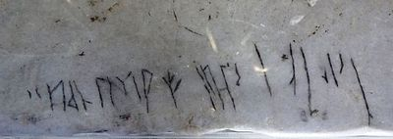

The "Halfdan inscription" - 2014

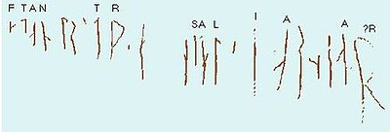

Transcription of the recognizable Halfdan runes

A second inscription was discovered by Folke Högberg from [Uppsala](http://www.wikiwand.com/en/Uppsala) in 1975. It was discovered in a niche in the northern part of the same gallery as the first inscription. The discovery was reported to the Department of Runes in [Stockholm](http://www.wikiwand.com/en/Stockholm) in 1984, but it was not published. The archaeologist Mats G. Larsson discovered the runes anew in 1988 and published the find in "Nyfunna runor i Hagia Sofia", *Fornvännen* 84 (1989), 12-14. He read *ari:k* and interpreted it as a possible "Ári m(ade)" or "Ári m(ade the runes)". Because of the uncertainty in the reading, the inscription was not registered in the periodical *Nytt om runer 4* of 1989.[[1]](http://www.wikiwand.com/en/Runic_inscriptions_in_Hagia_Sophia#citenoteknirk1)

Högberg had made a different reading from Larsson in 1975, and this reading was supported by Svein Indrelid, who is a professor of archaeology at the [University of Bergen](http://www.wikiwand.com/en/University_of_Bergen) in 1997. The reading of Högberg and Indrelid is the man's name *Árni* and they consider the inscription to be pure [graffiti](http://www.wikiwand.com/en/Graffiti), unlike Larsson. The latter learnt of Högberg's interpretation in 1989, but he defended his own interpretation.[[1]](http://www.wikiwand.com/en/Runic_inscriptions_in_Hagia_Sophia#citenoteknirk1)

The reasons for the runestone tradition are a matter of debate but they include inheritance issues, status and the honouring of the deceased. Several runestones explicitly commemorate inheritance such as the [Ulunda stone](http://www.wikiwand.com/en/Greece_runestones#U_792) and the [Hansta stone](http://www.wikiwand.com/en/Greece_runestones#U_73), but the vast majority of the runestones only tell who raised the stone and in memory of whom.

A view held by scholars such as [Erik Moltke](http://www.wikiwand.com/en/Erik_Moltke) and Sven B. F. Jansson holds that the runestones were primarily the result of the many Viking expeditions from Scandinavia,[[22]](http://www.wikiwand.com/en/Greece_runestones#citenotesawyer1622) or to cite Jansson (1987):

When the great expeditions were over, the old trade routes closed, and the Viking ships no longer made ready each spring for voyages to east and west, then that meant the end of the carving and setting up of rune stones in the proper sense of the term. They may be called the monuments of the Viking voyages, and the sensitive reader may catch in many of their inscriptions the Viking's love of adventure and exploits of boisterous daring.[[23]](http://www.wikiwand.com/en/Greece_runestones#citenote23)

Sawyer (2000), on the other hand, reacts against this commonly held view and comments that the vast majority of the runestones were raised in memory of people who are not reported to have died abroad.[[22]](http://www.wikiwand.com/en/Greece_runestones#citenotesawyer1622) She argues that few men who went abroad were honoured with memorials and the reason is that the runestones were mainly raised because of concerns at home, such as inheritance issues.[[24]](http://www.wikiwand.com/en/Greece_runestones#citenotesawyer11924) Such concerns would have arisen when a family knew that a relative would not return from abroad.[[25]](http://www.wikiwand.com/en/Greece_runestones#citenotesawyer15225)

The **Greece runestones** ([Swedish](http://www.wikiwand.com/en/Swedish_language): *Greklandsstenarna*, [Greek](http://www.wikiwand.com/en/Greek_language): *Ρουνικές λίθοι Ελλάδας*) are about 30 [runestones](http://www.wikiwand.com/en/Runestone) containing information related to voyages made by [Norsemen](http://www.wikiwand.com/en/Norsemen) to the [Byzantine Empire](http://www.wikiwand.com/en/Byzantine_Empire).

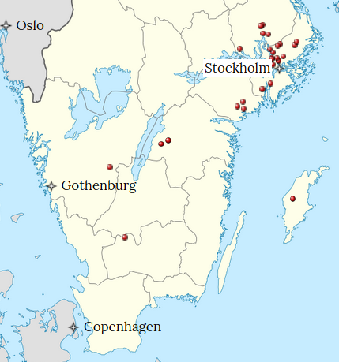

Distribution of Greece Runestones.

They were made during the [Viking Age](http://www.wikiwand.com/en/Viking_Age) until about 1100 and were engraved in the [Old Norse](http://www.wikiwand.com/en/Old_Norse) language with [Scandinavian runes](http://www.wikiwand.com/en/Younger_Futhark). All the stones have been found in modern-day [Sweden](http://www.wikiwand.com/en/Sweden), the majority in [Uppland](http://www.wikiwand.com/en/Uppland) (18 runestones) and [Södermanland](http://www.wikiwand.com/en/S%C3%B6dermanland) (7 runestones). Most were inscribed in memory of members of the [Varangian Guard](http://www.wikiwand.com/en/Varangian_Guard) who never returned home, but a few inscriptions mention men who returned with wealth, and a [boulder in Ed](http://www.wikiwand.com/en/Greece_runestones#U_112) was engraved on the orders of a former officer of the Guard.

On these runestones the word *Grikkland* ("[Greece](http://www.wikiwand.com/en/Greece)") appears in three inscriptions,[[1]](http://www.wikiwand.com/en/Greece_runestones#citenote1) the word *Grikk(j)ar* ("[Greeks](http://www.wikiwand.com/en/Greeks)") appears in 25 inscriptions,[[2]](http://www.wikiwand.com/en/Greece_runestones#citenote2) two stones refer to men as *grikkfari* ("traveller to Greece")[[3]](http://www.wikiwand.com/en/Greece_runestones#citenote3) and one stone refers to *Grikkhafnir* ("Greek harbours").[[4]](http://www.wikiwand.com/en/Greece_runestones#citenote4) Among other runestones which refer to expeditions abroad, the only groups which are comparable in number are the so-called "[England runestones](http://www.wikiwand.com/en/England_runestones)" that mention expeditions to England[[5]](http://www.wikiwand.com/en/Greece_runestones#citenoteJansson345) and the 26 [Ingvar runestones](http://www.wikiwand.com/en/Ingvar_runestones) that refer to a Viking expedition to the Middle East.

The stones vary in size from the small [whetstone from Timans](http://www.wikiwand.com/en/Greece_runestones#G_216) which measures 8.5 cm (3.3 in) × 4.5 cm (1.8 in) × 3.3 cm (1.3 in) to the boulder in Ed which is 18 m (59 ft) in circumference. Most of them are adorned with various [runestone styles](http://www.wikiwand.com/en/Runestone_styles) that were in use during the 11th century, and especially styles that were part of the [Ringerike style](http://www.wikiwand.com/en/Ringerike_style) (eight or nine stones[[6]](http://www.wikiwand.com/en/Greece_runestones#citenote6)) and the [Urnes style](http://www.wikiwand.com/en/Urnes_style) (eight stones[[7]](http://www.wikiwand.com/en/Greece_runestones#citenote7)).